**Experiment – 2.2**

**Student Name:** Deepak Saini **UID:** 20BCS4066

**Branch:** 20BCC1 **Section/Group:** A

**Semester:** 5th  **Date of Performance:** 19/09/2022

# Subject Name: Computer Networks Lab Subject Code: 20CSP-342

# 1.Aim/Overview of the Practical

Implement VLAN for a small organization which has the following two VLANs & 1 switch and 1 router.

1. VLAN HR, with a number 10 & which can be reached via a gateway 192.168.10.0

2. VLAN HR, with a number 20 & which can be reached via a gateway 192.168.20.0

# 2. Task to be Done

Implement VLAN for a small organization which has the following two VLANs & 1 switch and 1 router.

1. VLAN HR, with a number 10 & which can be reached via a gateway 192.168.10.0

2. VLAN HR, with a number 20 & which can be reached via a gateway 192.168.20.0

# 3. Application

# Requirements:

# PC

# Cisco Packet Tracer Software

# 4. Theory:

# A Virtual LAN (VLAN) is a logical LAN. VLANs have similar characteristics of physical LANs, only that with VLANs, you can logically group hosts even if they are physically located on separate LAN segments. We treat each VLAN as a separate subnet or broadcast domain. For this reason, to move packets from one VLAN to another, we have to use a router or a layer 3 switch. VLANs are configured on switches by placing some interfaces into one broadcast domain and some interfaces into another. We’ll configure 2 VLANs on a switch.

# We’ll then proceed and configure a router to enable communication between the two VLANs.

A trunk is a point-to-point link between two network devices that carry more than one VLAN. With VLAN trunking, you can extend your configured VLAN across the entire network. Most Cisco switches support the IEEE 802.1Q used to coordinate trunks on FastEthernet and GigabitEthernet.

To enable VLAN configured with trunk link to traffic frames between switches on the network, it is made possible by a link protocol called VLAN Trunking Protocol VTP.

VLAN Trunking Protocol (VTP) is a Cisco-proprietary link protocol, it provides a means by which Cisco switches can exchange VLAN configuration information. In effect, VTP advertises the existence of each VLAN based on its VLAN ID and the VLAN name. VTP serves a useful purpose, It enables the distribution of VLAN configuration among switches.

# 5. Steps for the practical/ Result/ Output:

1. Open the Cisco packet tracer application on your PC and login with your credentials.
2. Add 4 end-devices such that each 2- different networks are created with 2 PCs each and add a Router (1841).
3. Add a switch(switch- 2960) and add those all 4 end devices to this switch using fast ethernet cable.

# Create link between PCs-Switch and Router-Switch using the Straight-through wire selection. For each PC 1,2,3,4 select FastEthernet 0/1,0/2,0/3,0/4 respectively with their Fa0 connection. For Router select FastEthernet0/5 with its Fa0/0 connection.

1. Connect the PCs to the switch and configure their IP- addresses as in the figure such that their only host bit changes.

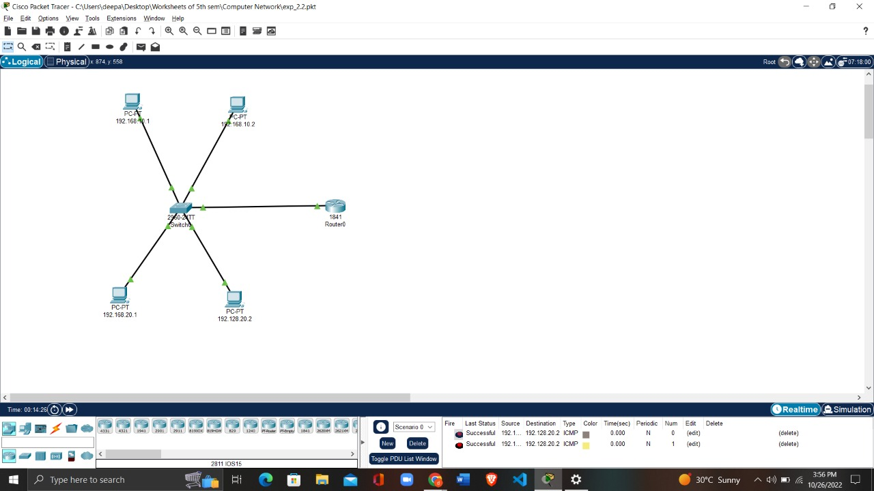

1. Open the each PC and give the default gateways as 192.168.10.10 to 1st network PC’s and 192.168.20.20 to2nd network PC’s.

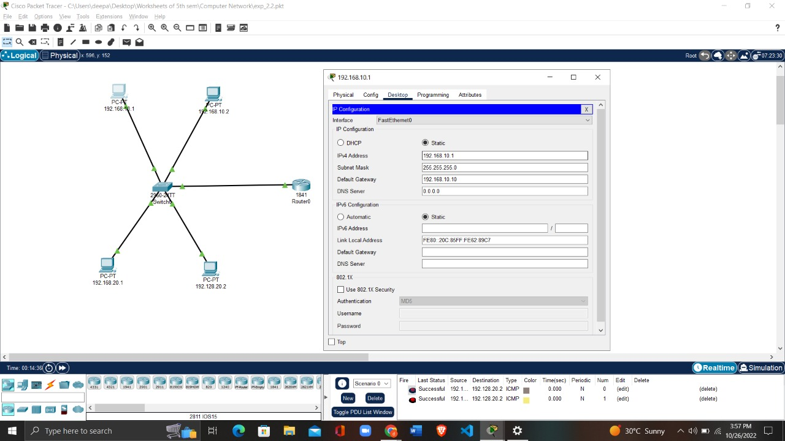

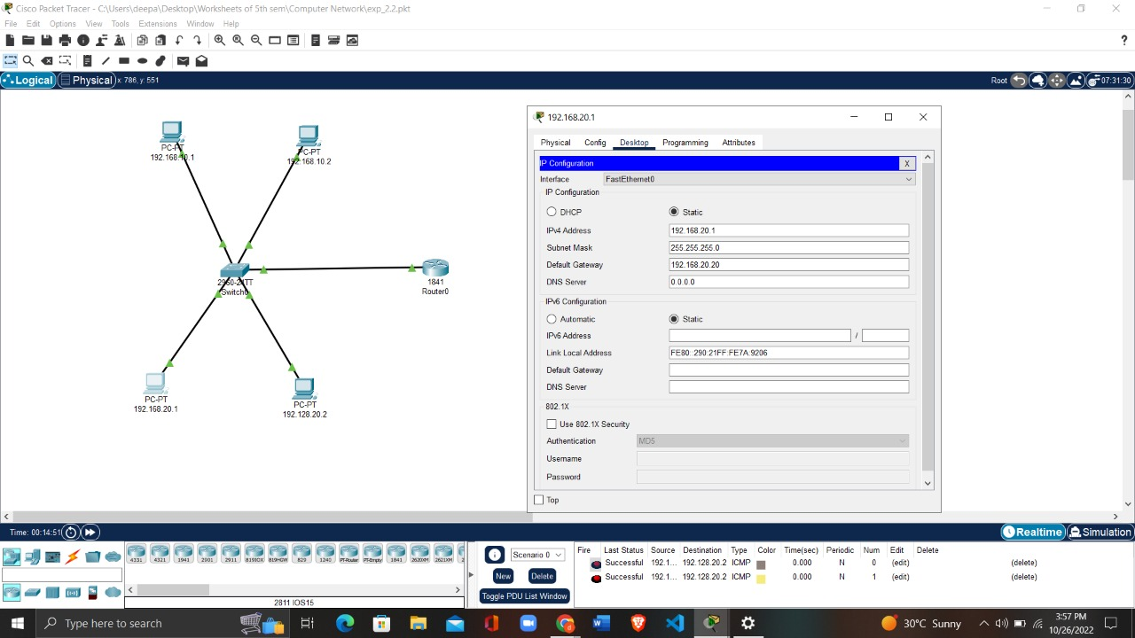

1. Now for creating VLANs

# Create 2 VLANs on the switch: VLAN 10 and VLAN 20. You can give them names of HR and IT respectively.

# Switch: Config-> VLAN Database:

# VLAN Number and VLAN Name:10-> HR

# VLAN Number and VLAN Name:20-> IT

# respectively.

# Then **Assign switch ports to the VLANs.**

# An access port is assigned to a single VLAN. These ports are configured for switch ports that connect to devices with a normal network card, for example a PC in a network.

# A trunk port on the other hand is a port that can be connected to another switch or router. This port can carry traffic of multiple VLANs.

So, open the switch configuration panel and go to CLI tab and do the following configuration:

# **Switch#config terminal**

# **Switch(config)#vlan 10**

# **Switch(config-vlan)#name HR**

# **Switch(config-vlan)#vlan 20**

# **Switch(config-vlan)#name IT**

# **Switch>enable**

# **Switch#config terminal**

# **Switch(config)#int fa0/1**

# **Switch(config-if)#switchport mode access**

# **Switch(config-if)#switchport access vlan 10**

# **Switch(config-if)#int fa0/4**

# **Switch(config-if)#switchport mode access**

# **Switch(config-if)#switchport access vlan 10**

# **Switch(config-if)#int fa0/2**

# **Switch(config-if)#switchport mode access**

# **Switch(config-if)#switchport access vlan 20**

# **Switch(config-if)#int fa0/3**

# **Switch(config-if)#switchport mode access**

# **Switch(config-if)#switchport access vlan 20**

# **Switch(config)#int fa 0/5**

# **Switch(config-if)#switchport mode trunk**

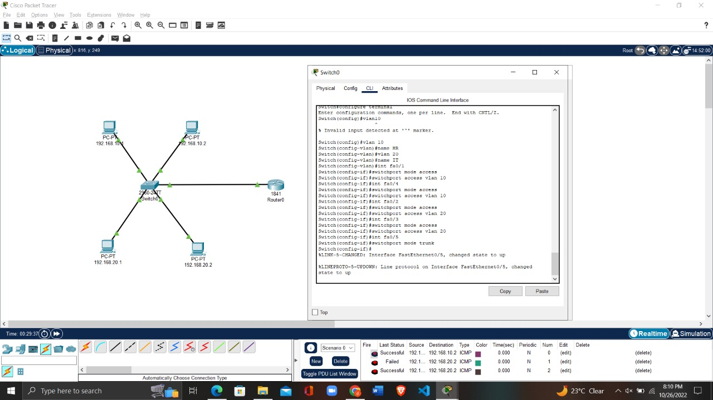

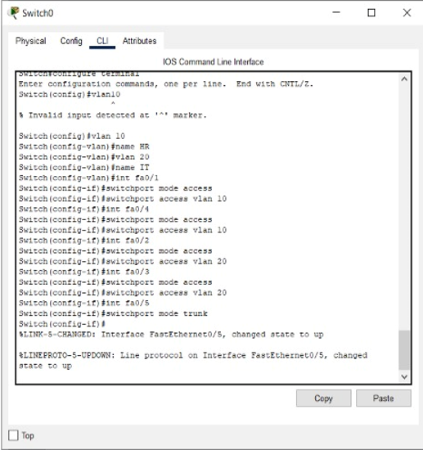

# **Switch interface fa0/5 is configured as trunk port with all available (1-1005) VLAN assigned,** **it will be used to carry traffic between the two VLANs via the router.**

# 

1. Now, let’s configure inter-VLAN routing by opening the router configuration panel and go to CLI tab and do the following configuration:

# Router>enable

# Router#config terminal

# Router(config)#int fa0/0

# Router(config-if)#no shutdown

# Router(config-if)#int fa0/0.10

# Router(config-subif)#encapsulation dot1q 10

# Router(config-subif)#ip add 192.168.1.1 255.255.255.0

# Router(config-subif)#

# Router(config-subif)#int fa0/0.20

# Router(config-subif)#encapsulation dot1q 20

# Router(config-subif)#ip add 192.168.2.1 255.255.255.0

# 

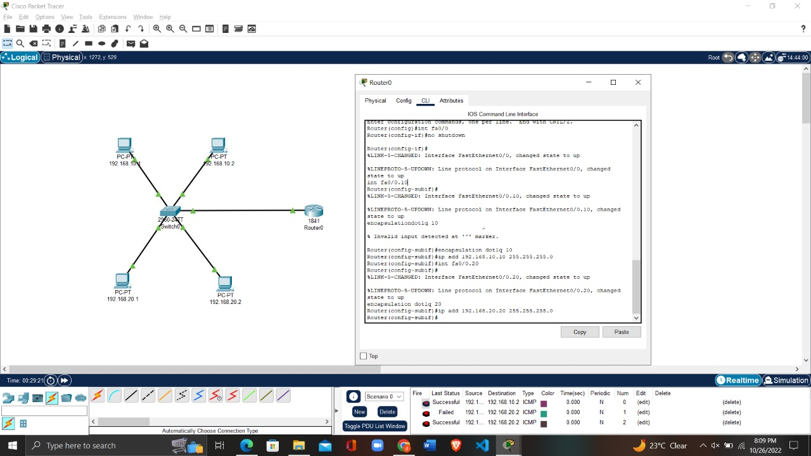

# 

# 

# Now, finally test inter-VLAN connectivity. Ping PC1 in VLAN 10 to PC4 in VLAN 20.

# 

# 

# Learning Outcomes:

# To successfully understand the basic networking concepts.

# To learn about working on Cisco Packet Tracer.

# To build a computer network and implement VLANs.

**Evaluation Grid (To be created as per the SOP and Assessment guidelines by the faculty):**

|  |  |  |  |
| --- | --- | --- | --- |
| Sr. No. | Parameters | Marks Obtained | Maximum Marks |
| 1. |  |  |  |
| 2. |  |  |  |
| 3. |  |  |  |
|  |  |  |  |